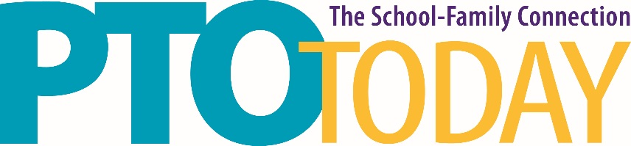

Columbus, OH February 19, 2020

OH Expo Center & State Fairgrounds
Lausche Building
Food Sampling Policy and Guidelines

Food and beverage product exhibitors who are lawful manufacturers or distributers of food and/or beverage products may distribute samples. Samples must be distributed from Exhibitors’ assigned space only. Samples may not exceed one bite-sized piece of a solid product, and two (2) ounces by volume of a non-alcoholic beverage product. Approval for distribution of samples must be obtained prior to an event.

Please Note: Temporary Food Service permits are not required at this location. However, the venue does require a list of exhibitors who will be sampling food and/or beverage and the item(s) to be sampled. Additionally, safe food handling and service is required.

Please email Susan Phillips at sphillips@ptotoday.com by February 5, 2020 with the following information:

- Company name
- Name of person exhibiting/sampling
- Product to be sampled

If you have any questions, contact Susan Phillips at the email address above or 800-644-3561 ext 207.

Please be aware that failure to adhere to the policy and timelines may prohibit you from sampling.

