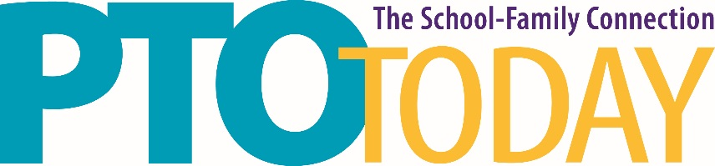

Columbus, OH February 19, 2020

OH Expo Center & State Fairgrounds

EXHIBITOR KIT

A Standard booth comes with a 6’ skirted table, two chairs and a waste basket. Double booths have two tables, etc. If you need something other than the items included with your booth, please read the procedure outlined below.

Fern Exposition – Fern Exposition is the official event decorator for the PTO Today Live Expo and your source for tables, chairs, floor coverings, and other booth accessories. Upon confirmation of your participation in the Expo, Fern will send an email to the address provided at registration that contains a link to their new OneView online ordering portal. If you have questions about Fern services or the ordering process, please contact Fern directly at 614-253-1500.

The email will come from exhibitorservices@fernexpo.com Please periodically check your spam or junk folders if you haven’t received their invitation.

