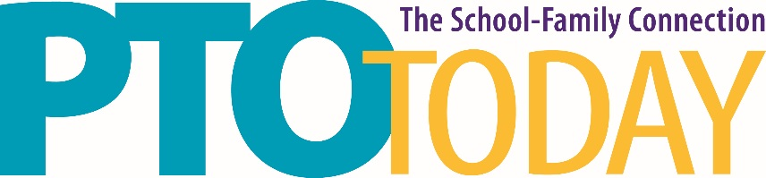

Oakbrook Terrace, IL February 4, 2020

Drury Lane Conference Center

Food Sampling Information

If you are sampling food please provide the following information to Tammy Blachuciak at t.blachuciak@drurylane.com by January 21, 2020.

- A copy of your business license

- A copy of a food handler’s certificate for the person who will be sampling

Temporary Food Service permits are not required at this location, however, safe food handling and service is required.

Please be aware that failure to adhere to safe food handling procedures may prohibit you from sampling.

