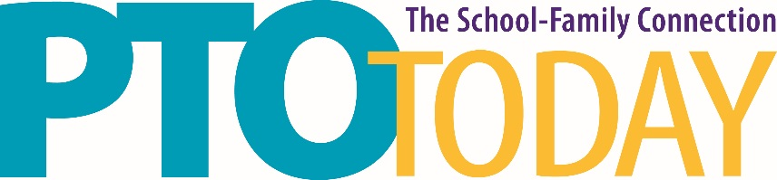

Lansing, MI April 14, 2020

Lansing Center

Food Sampling Information

Temporary Food Service permits are not required at this location. Exhibitors must follow safe food handling service procedures.

The following sampling procedures must be followed to avoid a Concessionaire’s fee or Buy Out fee:

- Food and beverage samples must be directly related to your participation in the expo.
- Only bite size samples are to be provided
- Food to be sampled must have been prepared in a licensed facility.
- Exhibitor must provide all service ware (napkins, forks, etc.)

If you have any questions, please contact Susan Phillips at sphillips@ptotoday.com or 800-644-3561 ext 207.

Please be aware that failure to adhere to safe food handling procedures may prohibit you from sampling.

